

GURU99 Dokumentimi

Prof:Muzafer Shala

Ass:Laberion Zebica Student:Albion Burrniku

Kampusi:Ferizaj

1.What is .NET Framework?

Eshte nje platforme e zhvillimit te softuerit e zhvilluar nga Microsoft per ndertimin dhe krijimin e applikacioneve te WINDOWS. .NET Framework perbehet nga mjete zhvilluese,gjuhe programuese dhe library per te ndertuar applikacione ne desktop dhe web.Perdoret gjithashtu per te ndertuar faqe ne internet,sherbime ne internet dhe lojera.

4.C# Hello World

using System;

namespace hellooworld

{

class Program

{

static void Main(string[] args)

{

Console.WriteLine("Hello World!");

}

}

}

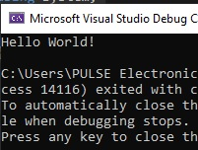

Advanced stuff

1. Data Types

1a.Integer

using System;

namespace integer

{

class Program

{

static void Main(string[] args)

{

Int32 num = 30;

Console.WriteLine(num);

}

}

}

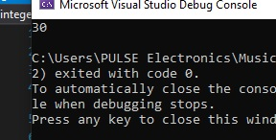

1b.Double

using System;

namespace Double

{

class Program

{

static void Main(string[] args)

{

double num = 30.33;

Console.WriteLine(num);

}

}

}

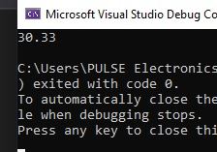

1c.Boolean

using System;

namespace boolean

{

class Program

{

static void Main(string[] args)

{

Boolean status = true;

Console.WriteLine(status);

}

}

}

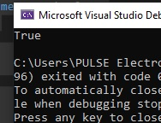

1d.String

using System;

namespace stringf

{

class Program

{

static void Main(string[] args)

{

string message = "Hello";

Console.WriteLine(message);

}

}

}

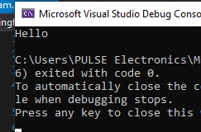

1. C# Enum

Enum-perdoret ne qdo gjuhe programuese per te percaktuar nje grup constant vlerash. P.sh ditet e javes mund te percaktohen sin je mumerim dhe te perdoren kudo ne program.

using System;

using System.Collections.Generic;

using System.Linq;

using System.Text;

using System.Threading.Tasks;

namespace Enu_m

{

class Program

{

enum Days { Sun, Mon, tue, Wed, thu, Fri, Sat };

static void Main(string[] args)

{

Console.Write( " {0}" , Days.Sun);

Console.ReadKey();

}

}

}

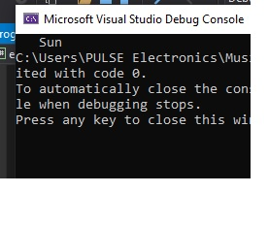

3)C# Variables Operators

using System;

using System.Collections.Generic;

using System.Linq;

using System.Text;

using System.Threading.Tasks;

namespace DemoApplication

{

class Program

{

static void Main(string[] args)

{

String message = "The value is ";

Int32 val = 30;

Console.Write(message + val);

Console.ReadKey();

}

}

}

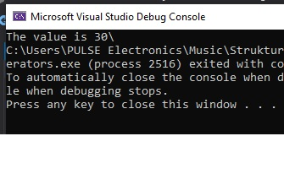

4)C# Conditional Statement

4.1)If Statement

using System;

using System.Collections.Generic;

using System.Linq;

using System.Text;

using System.Threading.Tasks;

namespace DemoApplication

{

class Program

{

static void Main(string[] args)

{

Int32 value = 11;

if (value < 10)

{

Console.WriteLine("Value is less than 10");

}

else

{

Console.WriteLine("Value is greater than 10");

}

Console.ReadKey();

}

}

}

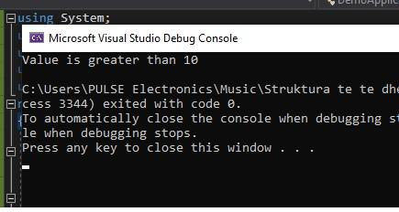

4.2)Switch Statement

using System;

using System.Collections.Generic;

using System.Linq;

using System.Text;

using System.Threading.Tasks;

namespace DemoApplication

{

class Program

{

static void Main(string[] args)

{

Int32 value = 11;

switch (value)

{

case 1:

Console.WriteLine("Value is 1");

break;

case 2:

Console.WriteLine("Value is 2");

break;

default:

Console.WriteLine("value is different");

break;

}

}

}

}

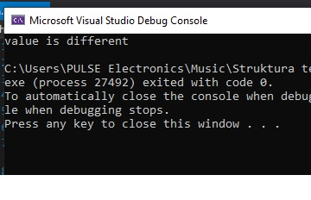

4.3)While Loop

using System;

using System.Collections.Generic;

using System.Linq;

using System.Text;

using System.Threading.Tasks;

namespace DemoApplication

{

class Program

{

static void Main(string[] args)

{

Int32 value = 3, i = 0;

while (i < value)

{

Console.WriteLine(i);

i = i + 1;

}

Console.ReadKey();

}

}

}

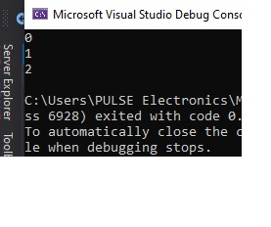

4.4)For Loop

using System;

using System.Collections.Generic;

using System.Linq;

using System.Text;

using System.Threading.Tasks;

namespace DemoApplication

{

class Program

{

static void Main(string[] args)

{

for(Int32 i=0;i<3;i++)

{

Console.WriteLine(i);

}

Console.ReadKey();

}

}

}

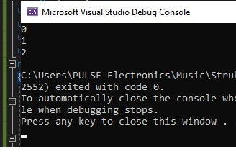

5)Arrays

using System;

using System.Collections.Generic;

using System.Linq;

using System.Text;

using System.Threading.Tasks;

namespace DemoApplication

{

class Program

{

static void Main(string[] args)

{

Int32[] value;

value = new Int32[3];

value[0] = 1;

value[1] = 2;

value[2] = 3;

Console.WriteLine(value[0]);

Console.WriteLine(value[1]);

Console.WriteLine(value[2]);

Console.ReadKey();

}

}

}

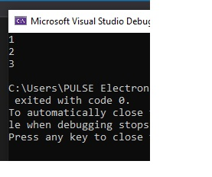

6)C# Class and Object

using System;

using System.Collections.Generic;

using System.Linq;

using System.Text;

using System.Threading.Tasks;

namespace DemoApplication

{

class Tutorial

{

int TutorialID;

string TutorialName;

public void SetTutorial(int pID, string pName)

{

TutorialID = pID;

TutorialName = pName;

}

public String GetTutorial()

{

return TutorialName;

}

static void Main(string[] args)

{

Tutorial pTutor = new Tutorial();

pTutor.SetTutorial(1, ".Net");

Console.WriteLine(pTutor.GetTutorial());

Console.ReadKey();

}

}

}

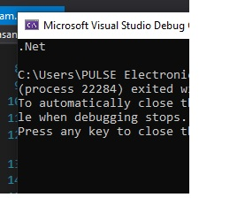

7)C#Access Modifiers and Constructor

using System;

using System.Collections.Generic;

using System.Linq;

using System.Text;

using System.Threading.Tasks;

namespace DemoApplication

{

class Tutorial

{

public int TutorialID;

public string TutorialName;

public Tutorial()

{

TutorialID = 0;

TutorialName = "Default";

}

public void SetTutorial(int pID, string pName)

{

TutorialID = pID;

TutorialName = pName;

}

public String GetTutorial()

{

return TutorialName;

}

static void Main(string[] args)

{

Tutorial pTutor = new Tutorial();

Console.WriteLine(pTutor.GetTutorial());

Console.ReadKey();

}

}

}

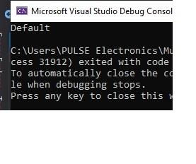

8)Inheritance

using System;

using System.Collections.Generic;

using System.Linq;

using System.Text;

using System.Threading.Tasks;

namespace DemoApplication

{

class Tutorial

{

protected int TutorialID;

protected string TutorialName;

public void SetTutorial(int pID, string pName)

{

TutorialID = pID;

TutorialName = pName;

}

public String GetTutorial()

{

return TutorialName;

}

}

public class Guru99Tutorial : Tutorial

{

public void RenameTutorial(String pNewName)

{

TutorialName = pNewName;

}

static void Main(string[] args)

{

Guru99Tutorial pTutor = new Guru99Tutorial();

pTutor.RenameTutorial(".Net by Guru99");

Console.WriteLine(pTutor.GetTutorial());

Console.ReadKey();

}

}

}

8.1)Polymorphism

using System;

using System.Collections.Generic;

using System.Linq;

using System.Text;

using System.Threading.Tasks;

namespace DemoApplication

{

class Tutorial

{

public int TutorialID;

public string TutorialName;

public void SetTutorial(int pID, string pName)

{

TutorialID = pID;

TutorialName = pName;

}

public void SetTutorial(string pName)

{

TutorialName = pName;

}

public String GetTutorial()

{

return TutorialName;

}

static void Main(string[] args)

{

Tutorial pTutor = new Tutorial();

pTutor.SetTutorial(1, "First Tutorial");

Console.WriteLine(pTutor.GetTutorial());

pTutor.SetTutorial("Second Tutorial");

Console.WriteLine(pTutor.GetTutorial());

Console.ReadKey();

}

}

}

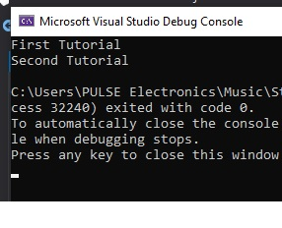

9)C# Abstract Classes

using System;

using System.Collections.Generic;

using System.Linq;

using System.Text;

using System.Threading.Tasks;

namespace DemoApplication

{

abstract class Tutorial

{

public virtual void Set()

{

}

}

class Guru99Tutorial : Tutorial

{

protected int TutorialID;

protected string TutorialName;

public void SetTutorial(int pID, string pName)

{

TutorialID = pID;

TutorialName = pName;

}

public String GetTutorial()

{

return TutorialName;

}

static void Main(string[] args)

{

Guru99Tutorial pTutor = new Guru99Tutorial();

pTutor.SetTutorial(1, ".Net");

Console.WriteLine(pTutor.GetTutorial());

Console.ReadKey();

}

}

}

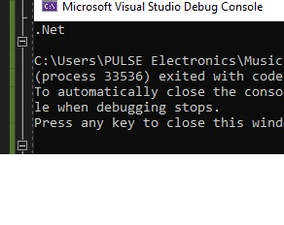

10)C# Interface

using System;

using System.Collections.Generic;

using System.Linq;

using System.Text;

using System.Threading.Tasks;

namespace DemoApplication

{

interface Guru99Interface

{

void SetTutorial(int pID, string pName);

String GetTutorial();

}

class Guru99Tutorial : Guru99Interface

{

protected int TutorialID;

protected string TutorialName;

public void SetTutorial(int pID, string pName)

{

TutorialID = pID;

TutorialName = pName;

}

public String GetTutorial()

{

return TutorialName;

}

static void Main(string[] args)

{

Guru99Tutorial pTutor = new Guru99Tutorial();

pTutor.SetTutorial(1, ".Net by Guru99");

Console.WriteLine(pTutor.GetTutorial());

Console.ReadKey();

}

}

}

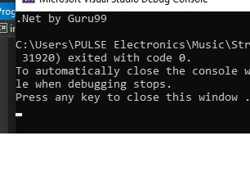

11)C# ArrayList

using System;

using System.Collections;

using System.Collections.Generic;

using System.Linq;

using System.Text;

using System.Threading.Tasks;

namespace DemoApplication

{

class Program

{

static void Main(string[] args)

{

ArrayList a1 = new ArrayList();

a1.Add(1);

a1.Add("Example");

a1.Add(true);

Console.WriteLine(a1[0]);

Console.WriteLine(a1[1]);

Console.WriteLine(a1[2]);

Console.ReadKey();

}

}

}

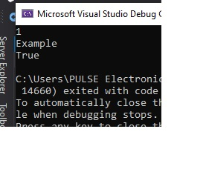

11.1) above-mentioned methods.

using System;

using System.Collections;

using System.Collections.Generic;

using System.Linq;

using System.Text;

using System.Threading.Tasks;

namespace DemoApplication

{

class Program

{

static void Main(string[] args)

{

ArrayList a1 = new ArrayList();

a1.Add(1);

a1.Add("Example");

a1.Add(true);

Console.WriteLine(a1.Count);

Console.WriteLine(a1.Contains(2));

Console.WriteLine(a1[1]);

a1.RemoveAt(1);

Console.WriteLine(a1[1]);

Console.ReadKey();

}

}

}

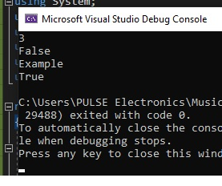

12)C#Stack1

using System;

using System.Collections;

using System.Collections.Generic;

using System.Linq;

using System.Text;

using System.Threading.Tasks;

namespace DemoApplication

{

class Program

{

static void Main(string[] args)

{

Stack st = new Stack();

st.Push(1);

st.Push(2);

st.Push(3);

foreach (Object obj in st)

{

Console.WriteLine(obj);

}

Console.WriteLine(); Console.WriteLine();

Console.WriteLine("The number of elements in the stack " +st.Count);

Console.WriteLine("Does the stack contain the elements 3 "+st.Contains(3));

Console.ReadKey();

}

}

}

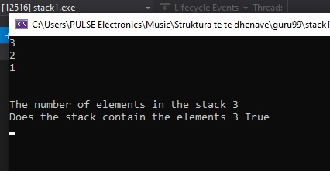

12.1) C# Stack2

using System;

using System.Collections;

using System.Collections.Generic;

using System.Linq;

using System.Text;

using System.Threading.Tasks;

namespace DemoApplication

{

class Program

{

static void Main(string[] args)

{

Stack st = new Stack();

st.Push(1);

st.Push(2);

st.Push(3);

st.Pop();

foreach (Object obj in st)

{

Console.WriteLine(obj);

}

Console.ReadKey();

}

}

}

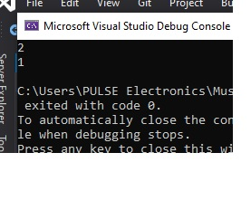

13)C# Queue

using System;

using System.Collections;

using System.Collections.Generic;

using System.Linq;

using System.Text;

using System.Threading.Tasks;

namespace DemoApplication

{

class Program

{

static void Main(string[] args)

{

Queue qt = new Queue();

qt.Enqueue(1);

qt.Enqueue(2);

qt.Enqueue(3);

foreach (Object obj in qt)

{

Console.WriteLine(obj);

}

Console.WriteLine(); Console.WriteLine();

Console.WriteLine("The number of elements in the Queue " + qt.Count);

Console.WriteLine("Does the Queue contain " + qt.Contains(3));

Console.ReadKey();

}

}

}

13.1) C# Queue Dequeue

using System;

using System.Collections;

using System.Collections.Generic;

using System.Linq;

using System.Text;

using System.Threading.Tasks;

namespace DemoApplication

{

class Program

{

static void Main(string[] args)

{

Queue qt = new Queue();

qt.Enqueue(1);

qt.Enqueue(2);

qt.Enqueue(3);

qt.Dequeue();

foreach (Object obj in qt)

{

Console.WriteLine(obj);

}

Console.ReadKey();

}

}

}

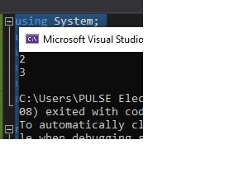

14)C# Hashtable

using System;

using System.Collections;

using System.Collections.Generic;

using System.Linq;

using System.Text;

using System.Threading.Tasks;

namespace DemoApplication

{

class Program

{

static void Main(string[] args)

{

Hashtable ht = new Hashtable();

ht.Add("001", ".Net");

ht.Add("002", "C#");

ht.Add("003", "ASP.Net");

ICollection keys = ht.Keys;

foreach (String k in keys)

{

Console.WriteLine(ht[k]);

}

Console.ReadKey();

}

}

}

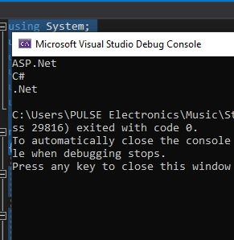

14.1) C# Hashtable2

using System;

using System.Collections;

using System.Collections.Generic;

using System.Linq;

using System.Text;

using System.Threading.Tasks;

namespace DemoApplication

{

class Program

{

static void Main(string[] args)

{

Hashtable ht = new Hashtable();

ht.Add("001", ".Net");

ht.Add("002", "C#");

ht.Add("003", "ASP.Net");

Console.WriteLine(ht.ContainsKey("001"));

Console.WriteLine(ht.ContainsValue("C#"));

Console.ReadKey();

}

}

}

